
UNIVERSITY OF ASIA PACIFIC
Department of CSE

Course Code: CSE 212
Course Title: Database Systems Lab
Project Name: Carbon Footprint and Sustainability Tracker Database Management System

Submitted By:
Tanvir Hasan Shehab: 23201031
Rajiya Sultana: 23201035
Samiuzzaman Shawon: 23201042
Namira Hossain: 23201047
Ahnaf Ahmed Taj: 23201052

Submitted to:
Nadeem Ahmed
Assistant Professor
Department of CSE
University of Asia Pacific

PROJECT TITLE: CARBON FOOTPRINT & SUSTAINABILITY TRACKER DATABASE MANAGEMENT SYSTEM

PROJECT DESCRIPTION
The Carbon Footprint and Sustainability Tracker Database Management System is designed to help individuals and organizations track, manage, and reduce their carbon emissions through a structured and data-driven approach.
In a time when global warming and environmental degradation are accelerating, it has become essential to understand how daily human activities contribute to carbon emissions. Despite widespread awareness, many people lack the tools to quantify their environmental impact or measure the results of their sustainable actions.
This system addresses that gap by providing a centralized database that records various activities such as transportation, energy consumption, food habits, and waste management and calculates the corresponding CO₂ emissions automatically. It also supports features like goal setting, donation tracking, project monitoring, rewards, and analytical reporting, making it a comprehensive sustainability tracking solution.
The database is structured using relational concepts with multiple interconnected tables to ensure data integrity, scalability, and easy retrieval of meaningful insights. Through this design, users and administrators can view patterns of emission, analyze project effectiveness, and promote sustainable living practices on both personal and community levels.
USER TYPE FOR OUR DATABASE
The system serves individuals, organizations, and authorities, connecting everyone through data to promote accountability, transparency, and sustainable living.

Core Objectives
- User and Activity Management
Maintain detailed records of users and their engagement in eco-friendly activities. Each activity is categorized under sectors like transportation, energy, or waste management, enabling clear tracking and comparison of individual environmental actions.
- Emission Tracking and Calculation
Accurately measure the carbon footprint of users based on their activities and predefined emission factors. This ensures transparent monitoring of individual and collective environmental impact over time.
- Goal and Progress Monitoring
Allow users to set personal sustainability goals and track progress over specific periods. The system supports linking activities to goals, helping users evaluate performance and stay motivated.
- Rewards and Motivation System
Encourage sustainable behavior through recognition and rewards. Users earn points, badges, or other incentives when they reach eco-friendly milestones, promoting ongoing participation.
- Project and Donation Management
Record details of green initiatives and track contributions from users. Each project’s environmental benefits are monitored, supporting transparent evaluation of the impact of donations and volunteer efforts.
- Reporting and Analytics
Generate comprehensive reports summarizing emissions, goal achievements, and project contributions. Analyze trends across categories to identify high-impact sectors and guide future sustainability efforts.
- Environmental Awareness and Education
Support campaigns, workshops, and educational programs by documenting initiatives across environmental categories. This encourages community engagement and knowledge sharing.
- Data Integrity and Relationship Management
Ensure structured relationships among all entities, maintaining consistency, reliability, and organized data across the system.
- Policy and Research Support
Provide accurate, structured data to support policymakers, NGOs, and researchers in analyzing emission patterns, assessing project effectiveness, and planning future sustainability strategies.
ENTITY RELATIONSHIP (ER) DESCRIPTIONS

1. Users – Goals
A user can set multiple goals to track their sustainability progress over time.
Relationship: One-to-Many (1 user → many goals)
2. Users – Reports
Each user can have multiple monthly reports summarizing their carbon emissions and progress.
Relationship: One-to-Many (1 user → many reports)

3. Users – User_Rewards
Users can claim multiple rewards based on their achievements or points earned. Relationship: One-to-Many (1 user → many user_rewards)
4. Users – User_Activities
A user can log many activities which record their daily carbon footprint contributions. Relationship: One-to-Many (1 user → many user_activities)
5. Users – Donations
Users may donate to multiple environmental projects to support sustainability efforts. Relationship: One-to-Many (1 user → many donations)
6. Categories – Projects
Each environmental project belongs to one category, such as Energy or Transportation. Relationship: One-to-Many (1 category → many projects)
7. Categories – Activities
Each activity belongs to one category, grouping similar carbon footprint sources. Relationship: One-to-Many (1 category → many activities)

8. Categories – Category_Statistics
Every category has one statistical record tracking average emissions and activity counts.
Relationship: One-to-One (1 category → 1 category_statistics)

9. Activities – User_Activities
An activity can be performed and logged multiple times by many users.
Relationship: One-to-Many (1 activity → many user_activities)
10. User_Activities – Emissions_Log
Each user activity log has a single corresponding emission record calculated from it.
Relationship: One-to-One (1 user_activity → 1 emissions_log)
11. Projects – Project_Impact
Projects generate multiple impact records describing environmental benefits like CO₂ saved.
Relationship: One-to-Many (1 project → many project_impacts)

12. Projects – Donations
Projects receive donations from multiple users supporting their sustainability goals.
Relationship: One-to-Many (1 project → many donations)
13. Rewards – User_Rewards
A reward can be claimed multiple times by different users through user_rewards records.

Relationship: One-to-Many (1 reward → many user_rewards)

14. Goals – Reports
A goal can be linked to multiple reports showing progress towards the goal.
Relationship: Many-to-Many (via Report_Goals junction table linking goals and reports)

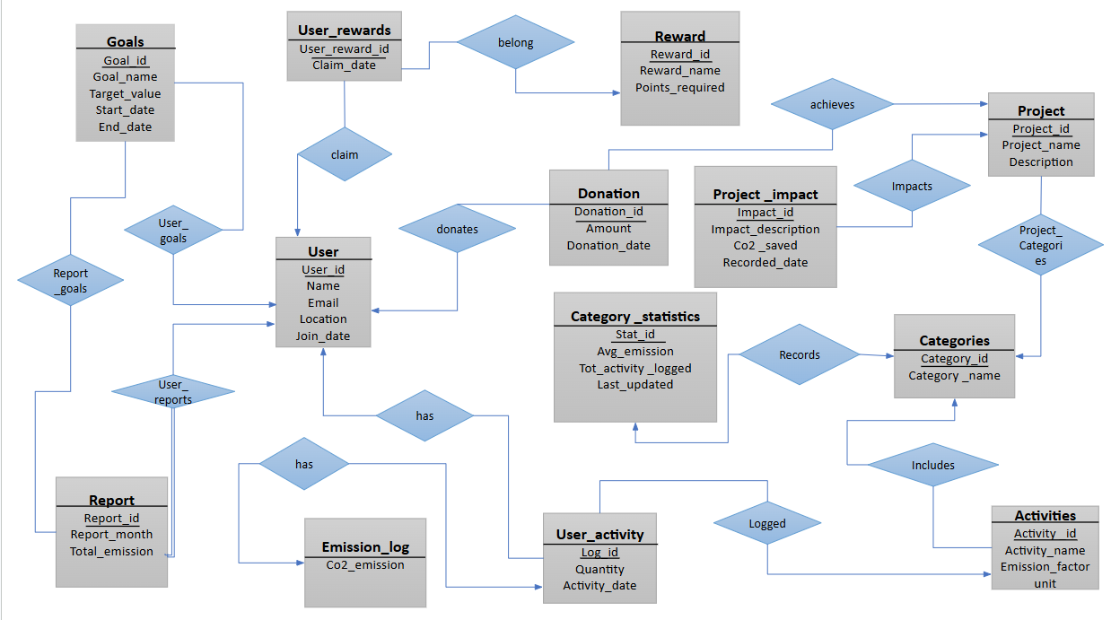
ER DIAGRAM

Table description
- Users
- PK: user_id
- Non-key attributes: name, email, location, join_date
- Description: Stores information about registered users of the platform.
- Categories
- PK: category_id
- Non-key attributes: category_name
- Description: Defines categories for activities and projects.
- Activities
- PK: activity_id
- FK: category_id
- Non-key attributes: activity_name, emission_factor, unit
- Description: Records different environmental activities and their CO₂ emission factors.
- User_Activities
- PK: log_id
- FK: user_id, activity_id
- Non-key attributes: quantity, activity_date
- Description: Tracks activities performed by users with their quantity and date.
- Emissions_Log
- PK: log_id
- FK: log_id
- Non-key attributes: co2_emission
- Description: Stores computed CO₂ emissions for each user activity.

- Goals
- PK: goal_id
- FK: user_id
- Non-key attributes: goal_name, target_value, start_date, end_date
- Description: Maintains sustainability goals set by users.
- Rewards
- PK: reward_id
- Non-key attributes: reward_name, points_required
- Description: Lists rewards available for users based on earned points.
- User_Rewards
- PK: user_reward_id
- FK: user_id, reward_id
- Non-key attributes: claim_date
- Description: Records rewards claimed by users.
- Projects
- PK: project_id
- FK: category_id
- Non-key attributes: project_name, description
- Description: Contains environmental projects and their details.
- Donations
- PK: donation_id
- FK: user_id, project_id
- Non-key attributes: amount, donation_date
- Description: Tracks monetary contributions made by users to projects.
- Reports
- PK: report_id
- FK: user_id
- Non-key attributes: report_month, total_emissions
- Description: Summarizes a user’s emissions over a reporting period.
- Project_Impact
- PK: impact_id
- FK: project_id
- Non-key attributes: impact_description, co2_saved, recorded_date
- Description: Records measurable environmental impacts of projects.
- Category_Statistics
- PK: stat_id
- FK: category_id
- Non-key attributes: average_emission, total_activities_logged, last_updated
- Description: Stores statistical summaries for each category.

- Report_Goals
- PK: (report_id, goal_id)
- FK: report_id, goal_id
- Description: Links reports to goals to track progress on each goal.

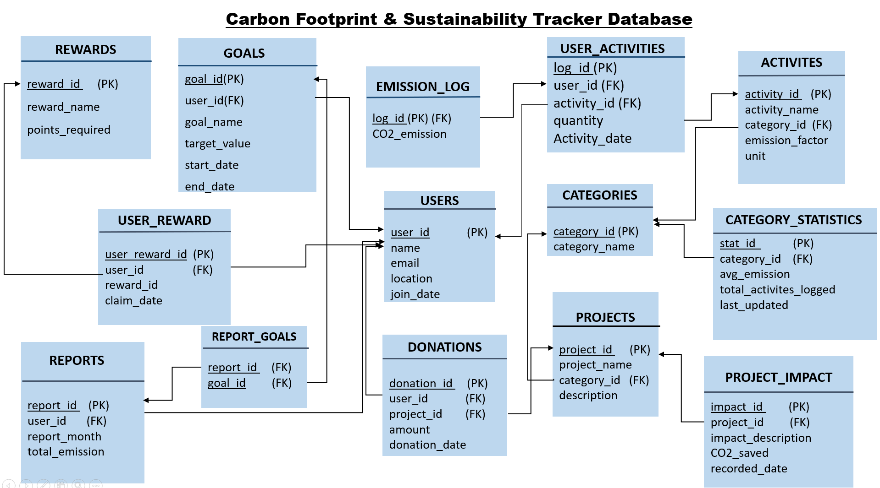
Schema Diagram
Database Creation:
Create database Carbon_Footprint
Table Creation:
create table users (
user_id int primary key,
name varchar(100),
email varchar(100) unique,
location varchar(100),
join_date date
)
GO
create table categories (
category_id int primary key,
category_name varchar(100) unique
)
GO
create table activities (
activity_id int primary key,

activity_name varchar(100),
category_id int,
emission_factor decimal(10,2),
unit varchar(100),
constraint activities_fk foreign key (category_id)
references categories(category_id)
)
GO
create table user_activities (
log_id int primary key,
user_id int,
activity_id int,
quantity decimal(10,2),
activity_date date,
constraint user_fk foreign key (user_id)
references users(user_id),
constraint activity_fk foreign key (activity_id)
references activities(activity_id)
)
GO
create table emissions_log (
log_id int primary key,
co2_emission decimal(10,2),
constraint log_fk foreign key (log_id)
references user_activities(log_id)
)
GO
create table goals (
goal_id int primary key,
user_id int,
goal_name varchar(100),
target_value decimal(10,2),
start_date date,
end_date date,
constraint goals_user_fk foreign key (user_id)
references users(user_id)
)
GO
create table rewards (
reward_id int primary key,
reward_name varchar(100),
points_required int
)
GO
create table user_rewards (
user_reward_id int primary key,
user_id int,
reward_id int,
claim_date date,
constraint ur_user_fk foreign key (user_id)
references users(user_id),
constraint ur_reward_fk foreign key (reward_id)
references rewards(reward_id)
)
GO
create table projects (
project_id int primary key,
project_name varchar(100),
category_id int,
description varchar(200),
constraint project_category_fk foreign key (category_id)
references categories(category_id)
)
GO
create table donations (
donation_id int primary key,
user_id int,
project_id int,
amount decimal(10,2),
donation_date date,
constraint donation_user_fk foreign key (user_id)
references users(user_id),
constraint donation_project_fk foreign key (project_id)
references projects(project_id)
)
GO
create table reports (
report_id int primary key,
user_id int,
report_month varchar(100),
total_emissions decimal(10,2),
constraint reports_user_fk foreign key (user_id)
references users(user_id)
)
GO
create table project_impact (
impact_id int primary key,
project_id int,
impact_description varchar(200),
co2_saved decimal(10,2),
recorded_date date,
constraint impact_project_fk foreign key (project_id)
references projects(project_id)
)
GO
create table category_statistics (
stat_id int primary key,
category_id int,
average_emission decimal(10,2),
total_activities_logged int,
last_updated date,
constraint stat_category_fk foreign key (category_id)
references categories(category_id)
)
GO
create table report_goals (
report_id int,
goal_id int,
constraint report_goals_pk primary key (report_id, goal_id),
constraint rg_report_fk foreign key (report_id)
references reports(report_id),
constraint rg_goal_fk foreign key (goal_id)
references goals(goal_id)
)
Data Insertion:
insert into [dbo].[users] values
(1, 'Ayesha Rahman', 'ayesha@example.com', 'Dhaka', '2024-01-10'),
(2, 'Tanvir Ahmed', 'tanvir@example.com', 'Chittagong', '2024-02-12'),
(3, 'Nadia Karim', 'nadia@example.com', 'Khulna', '2024-03-05'),
(4, 'Hasibul Islam', 'hasib@example.com', 'Sylhet', '2024-03-22'),
(5, 'Mithila Chowdhury', 'mithila@example.com', 'Rajshahi', '2024-04-01'),
(6, 'Rafi Khan', 'rafi@example.com', 'Dhaka', '2024-05-08'),
(7, 'Sadia Noor', 'sadia@example.com', 'Barishal', '2024-06-15'),
(8, 'Imran Hossain', 'imran@example.com', 'Rangpur', '2024-07-10'),
(9, 'Farzana Alam', 'farzana@example.com', 'Mymensingh', '2024-08-02'),
(10, 'Kamrul Hasan', 'kamrul@example.com', 'Dhaka', '2024-09-01');
select * from users
GO

insert into [dbo].[categories] values
(1, 'Renewable Energy'),
(2, 'Transportation'),
(3, 'Waste Management'),
(4, 'Food Consumption'),
(5, 'Water Usage'),
(6, 'Recycling'),
(7, 'Energy Efficiency'),
(8, 'Green Projects'),
(9, 'Sustainable Living'),
(10, 'Environmental Awareness');
select * from categories
GO
insert into [dbo].[activities] values
(1, 'Car Travel', 2, 2.31, 'km'),
(2, 'Bus Travel', 2, 0.12, 'km'),
(3, 'Electricity Usage', 1, 0.85, 'kWh'),
(4, 'Meat Consumption', 4, 27.00, 'kg'),
(5, 'Plastic Waste', 3, 6.00, 'kg'),
(6, 'Water Usage', 5, 0.35, 'liter'),
(7, 'Online Shopping', 9, 1.80, 'order'),
(8, 'Flight Travel', 2, 90.00, 'hour'),
(9, 'Paper Use', 6, 0.10, 'sheet'),
(10, 'Solar Power Generation', 1, -0.50, 'kWh');
select * from activities
GO

insert into [dbo].[user_activities] values
(1, 1, 1, 15, '2025-10-01'),
(2, 1, 3, 120, '2025-10-02'),
(3, 2, 2, 30, '2025-10-01'),
(4, 2, 4, 2, '2025-10-03'),
(5, 3, 5, 5, '2025-10-04'),
(6, 3, 6, 100, '2025-10-05'),
(7, 4, 7, 3, '2025-10-06'),
(8, 4, 8, 2, '2025-10-07'),
(9, 5, 9, 50, '2025-10-08'),
(10, 5, 10, 100, '2025-10-09'),
(11, 6, 1, 20, '2025-10-10'),
(12, 6, 4, 3, '2025-10-11');
select * from user_activities

GO
insert into [dbo].[projects] values
(1, 'Solar Roof Initiative', 1, 'Install solar panels in schools'),
(2, 'Urban Bicycle Campaign', 2, 'Promote bicycle use in cities'),
(3, 'Waste Segregation Drive', 3, 'Community waste management project'),
(4, 'Plant-Based Meal Week', 4, 'Promote plant-based meals in offices'),
(5, 'Water Saving Campaign', 5, 'Awareness on water conservation'),
(6, 'Plastic Recycling Program', 6, 'Local plastic recycling centers'),
(7, 'Energy-Efficient Lighting', 7, 'Replace bulbs with energy-saving LEDs'),
(8, 'Tree Plantation Drive', 8, 'Plant trees in public parks'),
(9, 'Minimal Plastic Lifestyle', 9, 'Reduce single-use plastic usage'),
(10, 'Environmental Workshop', 10, 'Conduct environmental awareness workshops'),
(11, 'Solar Water Heaters', 1, 'Install solar water heating systems in homes'),
(12, 'Public Transport Awareness', 2, 'Promote bus and train usage to reduce car travel');
select * from projects
GO
insert into [dbo].[donations] values
(1, 1, 1, 8000, '2025-10-07'),
(2, 1, 11, 5000, '2025-10-08'),
(3, 2, 2, 6000, '2025-10-09'),
(4, 2, 12, 4500, '2025-10-10'),
(5, 1, 1, 3000, '2025-10-12'),
(6, 3, 8, 5000, '2025-10-13'),
(7, 2, 2, 4000, '2025-10-14'),
(8, 3, 3, 3500, '2025-10-15');
select * from donations
GO
insert into [dbo].[project_impact] values
(1, 1, 'Solar panels installed in schools', 1200.50, '2025-10-17'),
(2, 11, 'Solar water heaters installed in homes', 800.75, '2025-10-18'),
(3, 2, 'Promoted bicycle use in city', 950.00, '2025-10-09'),
(4, 12, 'Public transport awareness campaigns', 700.25, '2025-10-10'),
(5, 1, 'Additional solar panels in schools', 450.30, '2025-10-12'),
(6, 8, 'Tree plantation drive impact', 600.00, '2025-10-13'),
(7, 2, 'Extended bicycle campaign', 400.50, '2025-10-16'),
(8, 3, 'Community waste management improvements', 550.80, '2025-10-15'),
(9, 4, 'Plant-based meals promoted in offices', 300.50, '2025-10-19'),
(10, 5, 'Water conservation awareness campaign', 150.00, '2025-10-20'),
(11, 6, 'Plastic recycling centers operational', 400.25, '2025-10-21'),
(12, 7, 'Energy-efficient lighting installed in offices', 250.75, '2025-10-22'),
(13, 9, 'Reduced single-use plastic in community', 180.00, '2025-10-23'),
(14, 10, 'Environmental workshops conducted', 220.50, '2025-10-24');
select * from project_impact

GO
insert into [dbo].[category_statistics] values
(1, 1, 0.18, 2, '2025-10-17'),
(2, 2, 30.14, 4, '2025-10-17'),
(3, 3, 6.00, 1, '2025-10-17'),
(4, 4, 27.00, 1, '2025-10-17'),
(5, 5, 0.35, 1, '2025-10-17'),
(6, 6, 0.10, 1, '2025-10-17'),
(7, 7, 90.00, 1, '2025-10-17'),
(8, 8, 0, 1, '2025-10-17'),
(9, 9, 1.80, 1, '2025-10-17');
select * from category_statistics

GO
insert into [dbo].[goals] values
(1, 1, 'Reduce Car Travel CO2', 50.00, '2025-10-01', '2025-12-31'),
(2, 1, 'Install Solar Panels', 100.00, '2025-10-01', '2025-12-31'),
(3, 2, 'Use Public Transport', 200.00, '2025-10-01', '2025-12-31'),
(4, 3, 'Reduce Plastic Waste', 15.00, '2025-10-01', '2025-12-31'),
(5, 4, 'Adopt Plant-Based Meals', 20.00, '2025-10-01', '2025-12-31'),
(6, 5, 'Reduce Paper Use', 30.00, '2025-10-01', '2025-12-31'),
(7, 6, 'Reduce Electricity Usage', 100.00, '2025-10-01', '2025-12-31'),
(8, 7, 'Plant Trees', 50.00, '2025-10-01', '2025-12-31'),
(9, 8, 'Minimize Plastic Orders', 25.00, '2025-10-01', '2025-12-31'),
(10, 9, 'Promote Environmental Awareness', 0, '2025-10-01', '2025-12-31');
select * from goals

GO
insert into [dbo].[rewards] values
(1, 'Tree Planter Badge', 500),
(2, 'Eco Warrior Badge', 1000),
(3, 'Water Saver Badge', 700),
(4, 'Carbon Reducer Badge', 1200),
(5, 'Public Transport Hero', 900),
(6, 'Solar Supporter', 1500),
(7, 'Recycling Champion', 800),
(8, 'Green Volunteer', 600),
(9, 'Sustainability Star', 2000),
(10, 'Planet Protector Medal', 2500);
select * from rewards

GO
insert into [dbo].[user_rewards] values
(1, 1, 1, '2025-10-10'),
(2, 1, 2, '2025-10-12'),
(3, 2, 3, '2025-10-13'),
(4, 3, 7, '2025-10-14'),
(5, 3, 8, '2025-10-15'),
(6, 4, 4, '2025-10-16'),
(7, 5, 5, '2025-10-17'),
(8, 6, 6, '2025-10-18'),
(9, 7, 9, '2025-10-19'),
(10, 8, 10, '2025-10-20'),
(11, 2, 2, '2025-10-21'),
(12, 5, 1, '2025-10-22');
select * from user_rewards

GO
insert into [dbo].[reports] values
(1, 1, 'October 2025', 520.75),
(2, 2, 'October 2025', 610.50),
(3, 3, 'October 2025', 430.25),
(4, 4, 'October 2025', 480.60),
(5, 5, 'October 2025', 395.40),
(6, 6, 'October 2025', 505.80),
(7, 7, 'October 2025', 370.20),
(8, 8, 'October 2025', 440.35),
(9, 9, 'October 2025', 460.90),
(10, 10, 'October 2025', 415.00);
select * from reports

GO
insert into [dbo].[report_goals] values
(1, 1),
(1, 2),
(2, 3),
(3, 4),
(4, 5),
(5, 6),
(6, 7),
(7, 8),
(8, 9),
(9, 10),
(10, 6),
(10, 1);
select * from report_goals

GO
insert into emissions_log (log_id, co2_emission)
select ua.log_id, ua.quantity * a.emission_factor
from user_activities ua
join activities a on ua.activity_id = a.activity_id;
select * from emissions_log

Query (Question, DML query, Output Screenshot):
  - Shows all user names.
select name
from users
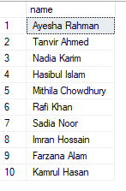
  - Display each location only once (no duplicates).
select distinct location
from users
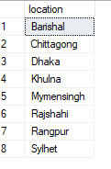
  - Display activities table.
select * from activities
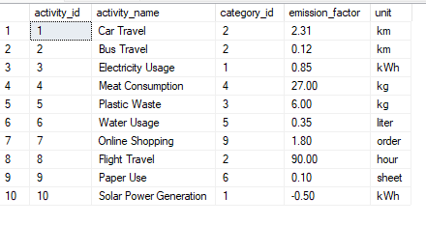
  - Show users who live in Dhaka.
select name, email
from users
where location = 'Dhaka';
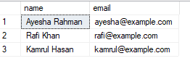
  - Show each user’s name along with the activity_id they performed.
select name, activity_id
from users, user_activities
where users.user_id = user_activities.user_id;

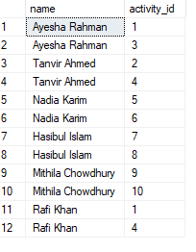
  - Find users whose name contains the letter i
select name
from users
where name like '%i%';
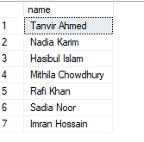

  - Order users by their join date
select name, email, location, join_date
from users
order by join_date desc;
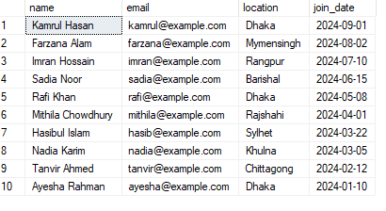
  - Retrieve all user activities with quantities between 10 and 50.
select user_id, activity_id, quantity, activity_date
from user_activities
where quantity between 10 and 50;
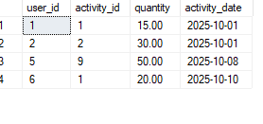
  - Write a SQL query to display the names of all projects that belong to either category 1 or category 2.
(select project_name from projects where category_id = 1)
union
(select project_name from projects where category_id = 2);

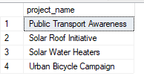

  - Find the user IDs that appear in both groups, those who have activity quantities between 10 and 50 and also between 30 and 100.
(select user_id from user_activities where quantity between 10 and 50)
intersect
(select user_id from user_activities where quantity between 30 and 100);
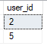
  - Find the user IDs who have activities with quantities greater than 20 but not greater than 50.
(select user_id from user_activities where quantity > 20)
except
(select user_id from user_activities where quantity > 50);
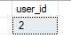
  - Count number of activities per user
select user_id, count(activity_id) as total_activities
from user_activities
group by user_id;

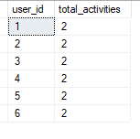

  - Display the donor’s name, project name, donation amount, and donation date for all donations. Sort the results by donation date in descending order.
select u.name as donor_name, p.project_name, d.amount, d.donation_date
from donations d
join users u on d.user_id = u.user_id
join projects p on d.project_id = p.project_id
order by d.donation_date desc;
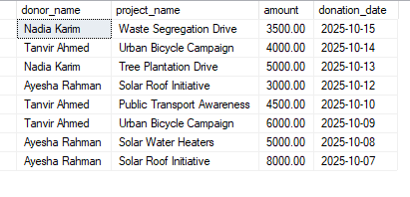
  - Maximum donation per user.
select u.name as donor_name, max(d.amount) as max_donation
from users u
join donations d on u.user_id = d.user_id
group by u.name;
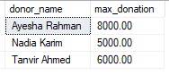
  - Show average donation amount.
select avg(amount) as average_donation
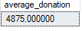
from donations;

  - Rank users from highest to lowest donor.
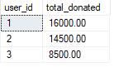
  - Find total CO2 saved per project
select project_name,
(select sum(co2_saved)
from project_impact pi
where pi.project_id = p.project_id) as total_co2_saved
from projects p
order by total_co2_saved desc;
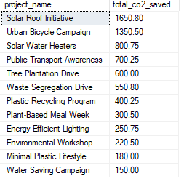
  - Show each user’s goals and their target emissions.
select u.user_id, u.name, g.goal_name, g.target_value, g.start_date, g.end_date
from users u
join goals g on u.user_id = g.user_id;

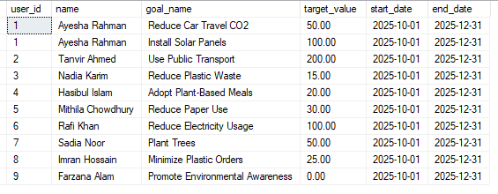
  - What is the total CO2 emissions for all users?
select sum(total_emissions) as Total_CO2_Emissions
from reports;
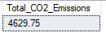
  - Find average co₂ emission for all users.
select avg(e.co2_emission) as average_co2_emission
from emissions_log e;
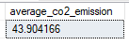
  - What is the total emission per user?
select u.name, sum(e.co2_emission) as total_emission
from users u
join user_activities ua on u.user_id = ua.user_id
join emissions_log e on ua.log_id = e.log_id
group by u.name
order by total_emission desc;
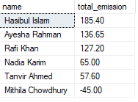

  - What is the maximum co₂ emission per user?
select u.name as user_name, max(e.co2_emission) as max_emission
from users u
join user_activities ua on u.user_id = ua.user_id
join emissions_log e on ua.log_id = e.log_id
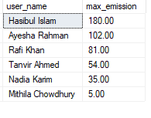
group by u.name order by max_emission desc;

  - What is the minimum co₂ emission per user?
select u.name as user_name, min(e.co2_emission) as min_emission
from users u
join user_activities ua on u.user_id = ua.user_id
join emissions_log e on ua.log_id = e.log_id
group by u. name;
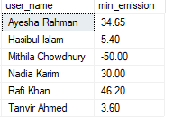
  - Display users who participated in activities of more than one category.
select u.name,
count(distinct a.category_id) as categories_involved
from users u
join user_activities ua on u.user_id = ua.user_id
join activities a on ua.activity_id = a.activity_id
group by u.name
having count(distinct a.category_id) > 1;
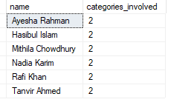
  - Write an update query.
update user_activities
set quantity = quantity * 1.10
where quantity < 50;
select * from user_activities
After update:
Before update:
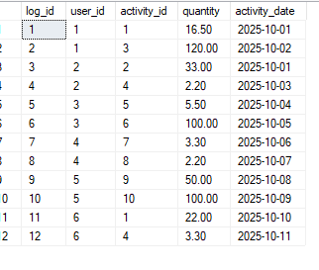
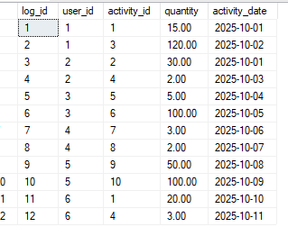

  - Trigger: Auto-calculate CO₂ when new activity is added.
create trigger trg_addemission
on user_activities
after insert
as
begin
insert into emissions_log(log_id, co2_emission)
select
i.log_id,
i.quantity * a.emission_factor
from inserted i
join activities a on i.activity_id = a.activity_id;
end;

insert into user_activities (log_id, user_id, activity_id, quantity, activity_date)
values (13, 2, 1, 10, '2025-10-22')

select * from user_activities
select * from emissions_log
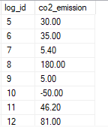
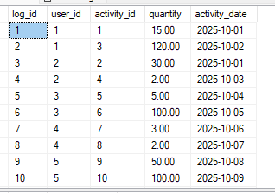

  - View: Emissions by Activity.
create view vw_activityemissions as
select
a.activity_name,
sum(e.co2_emission) as total_emission
from activities a
join user_activities ua on a.activity_id = ua.activity_id
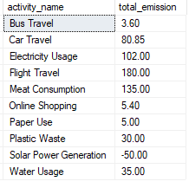
join emissions_log e on ua.log_id = e.log_id
group by a.activity_name;

select* from vw_activityemissions;

K-P-A MAPPING

KNOWLEDGE PROFILE (K)
Knowledge Attribute | How the Project is Mapped to the Attribute
K3 – Engineering Fundamentals | Applied fundamental database design and SQL concepts to develop relational tables (users, activities, emissions_log) and ensure data consistency.
K5 – Knowledge Supporting Design | Designed and normalized the database schema through ER modeling and implemented relations between entities (users, activities, goals, projects) to meet real-world environmental needs.
K6 – Engineering Practice & Tools | Used Microsoft SQL Server as the primary database tool to create, manipulate, and query data efficiently, applying professional practices like constraints and normalization.
K7 – Ethical & Sustainability Awareness | Incorporated sustainability and social responsibility by designing a system that tracks and promotes eco-friendly actions, encouraging awareness of carbon reduction.

Range of Complex Engineering Problem Solving (P)
Problem-Solving Attribute | How the Project is Mapped to the Attribute
P1 – In-Depth Engineering Problem Solving | Identified the real-world issue of measuring and managing carbon emissions and built a structured database to analyze users’ environmental impact.
P3 – Abstract Thinking & Modeling | Developed an ER diagram and implemented foreign key relationships to model complex sustainability data connections among multiple entities.
P7 – Interdependent Problem Integration | Managed interrelated database components (users, activities, donations, projects, reports) to form an integrated sustainability tracking system.

Range of Complex Engineering Activities (A)

Activity Attribute | How the Project is Mapped to the Attribute
A1 – Teamwork & Resource Use | Worked collaboratively in a team to design, test, and document the database using diverse data and SQL Server resources.
A4 – Social & Environmental Impact | Created a system that raises environmental awareness and supports sustainability goals through data visualization and analysis.
A5 – Applying Principles to Real Contexts | Applied database concepts and SQL principles creatively to a real-life sustainability scenario, going beyond classroom examples.

